**Decimals**

A decimal is a fraction whose denominator is a power of 10.

**Express as decimal**

a) Express the following fraction as a decimal     ⅜

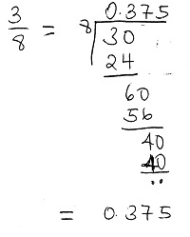

**Express decimals as fractions**

a) Express the following decimal as a fraction     **0.355**

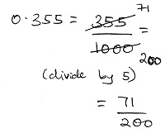

b) Express the following decimal as a fraction     **3.24**

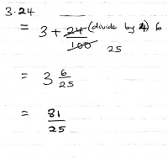

**Recurring Decimals**

An example of a recurring decimal is 0.83333 and can be represented as 0.83  
a) Express the recurring decimal as fraction     **0.632 (two digits recurring)**

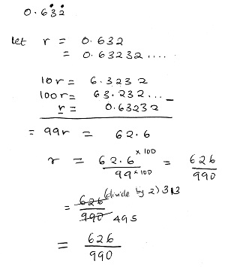

**Decimal Places**

Decimals will be rounded off to a certain degree of accuracy Example: Round off   **5.936**   to  
(a) 1dp (b) 2dp and (c) 3dp

a) 6.0  
b) 5.90  
c) 5.940

**Standard Form**

Writing numbers to be between 1 and 10 times a power of 10.  
Write the following numbers in standard form  
a)589  
b) 0.00488

a) 5.89 x 102  
b) 4.88 x 10-3

**Standard Form**

**Addition and Subtraction**  
It is basic operations as integers

0.5832 + 1.859 = 2.4422